Scholarship: English Teacher Volunteers
For Non-Native Europeans Kingston Crown International
400,000 THB per year

We are a charity organization financially supported by a private enterprise. We provide English courses for underprivileged Thai students from poor schools in our locality. The students are trained to focus on both academic excellence and spiritual balance.
Our expertise in organizing English courses at the national level “Annual Intensive CEFR English Course for 450 Thai English teachers from 250 schools, authorized and sponsored by Education Authority – Area 1, Ubon” can guarantee our quality education services.
We have established a partnership with our local Catholic Congregation whereby KCI recruits and trains English teachers for five of their schools. The teachers will undergo extensive TEFL training as well as working at Kingston Crown. Working at one of the Congregation's schools will be one of teacher's additional assignments. We urgently need to recruit 10 well-motivated teachers to help Thai students who don't have access to an authentic English speaking environment.
Requirements
- C1 level in English (CEFR).
- A Non-native European, single, 17-27 years old.
- At least high school educated.
- A quick learner with humility and a passion for teaching.
- Cheerful, open-minded, honest and creative.
- Willing to share a community life at KCI.
- Kind-hearted with experience of charity work is an advantage.

Benefits
N.O | Description | Allowance | Paid by KCI
1 | Living allowance | 144,000 THB/yr
2 | TEFL Course Training (300 hours/yr) |  | 93,000 THB/yr
3 | Free accommodation with air con, laundry & internet |  | 70,000 THB/yr
4 | Return flight tickets (reimbursed after 1 year). |  | 20,000 THB/yr
5 | 3 meals a day. |  | 50,000 THB/yr
6 | Tours camping (once a month) |  | 12,000 THB/yr
7 | Health Insurance provided by Ministry of Labor |  | 11,000 THB/yr
8 | Visa & work permit assistance. | N/A | N/A
9 | TEFL and Certificate of Achievement will be awarded for your work reference. | N/A | N/A
10 | Genuine career path opportunities for successful candidates Scholarships for higher education in Thailand, other professional trainings & become a member of the board of directors. | N/A | N/A
Total |  | 144,000 THB/yr | 256,000 THB/yr
 |  |  | 400,000 THB/yr
Job Description:
- Organizing English games/activities : 23 hrs/week
- Variable office hours : Approximately 8 hrs/day ( Wed – Sun); Holiday: Mon-Tue
- Attending TEFL training classes : 10 hrs/wk
- Joining English camps & activities.
Please send a cover letter, resume, a recent photo, a copy of passport,
teaching certificate (if any), or relevant documents and references to…
Maitree Jeremy E-mail : kingston2497@yahoo.com Facebook : Kingston Crown

Kingston Crown International THE CONGREGATION OF THE LOVERS OF THE CROSS

--------------------------------------------------------------------------------------------------------------------------------------------------------------------
Maris Stella Project: The Five Partner Schools
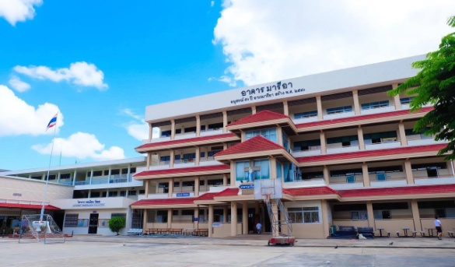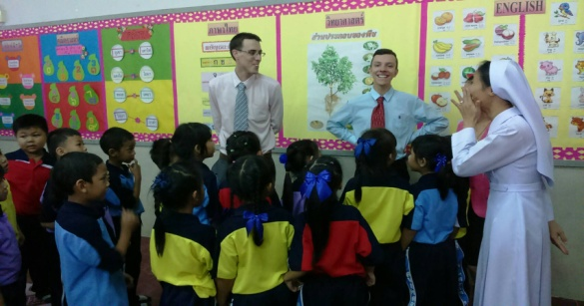
3. Marie Uptatham, Kantralak
Total Students: 1,316
Website: www.mu.ac.th/home

2. Ave Marie, Amnat Chareon
Total Students: 1,062
Website: www.aveamnat.ac.th

1. Ave Marie, Ubon Rathcathani
Total Students: 1,519
Website: www.avemaria.ac.th

5. Marie Niramon, Ubon Ratchathani
Total Students: 1,065
Website: www.niramon.ac.th

4. Marie Wittaya, Sisaket
Total Students: 2,592
Website: www.marie.ac.th

KCI CEFR English Course
August/September 2015
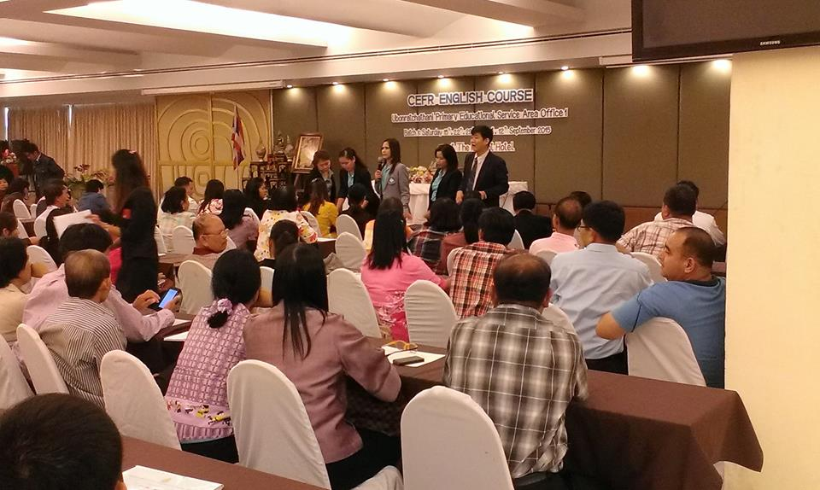 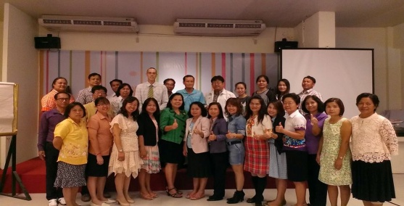

- CEFR Seminar organised for 400 Thai English teachers from 250 schools in Ubon Ratchathani, August 2015.
TEFL Teaching Demonstrations
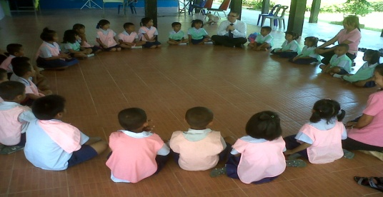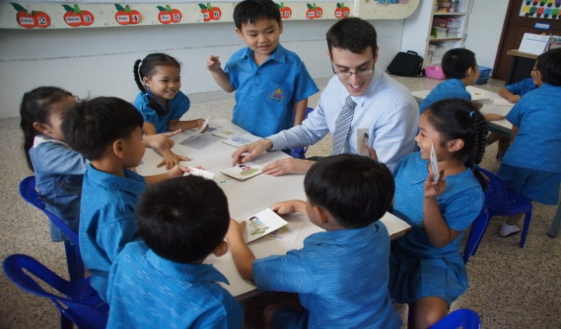
Voluntary teaching demonstrations in rural schools.

Kingston Crown International THE CONGREGATION OF THE LOVERS OF THE CROSS
--------------------------------------------------------------------------------------------------------------------------------------------------------------------
English Activities & Camps
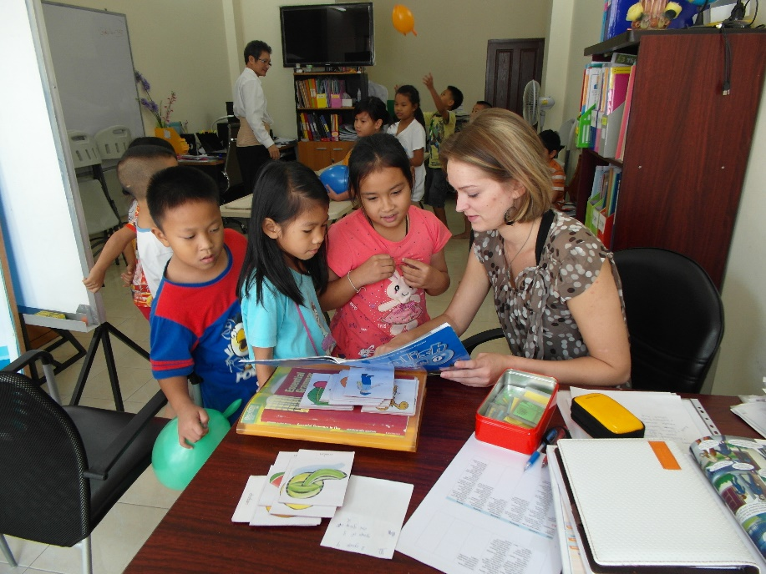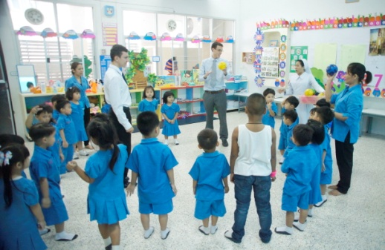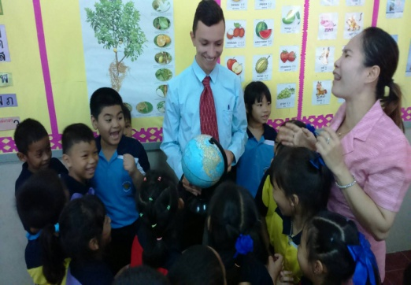
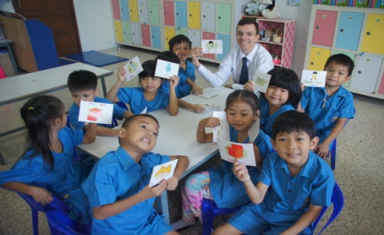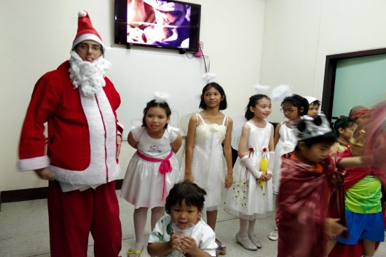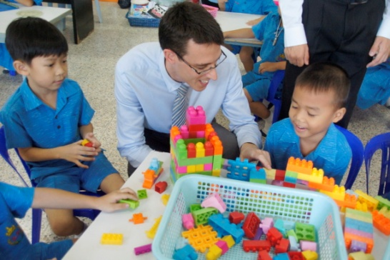
KCI Teachers' Testimonials
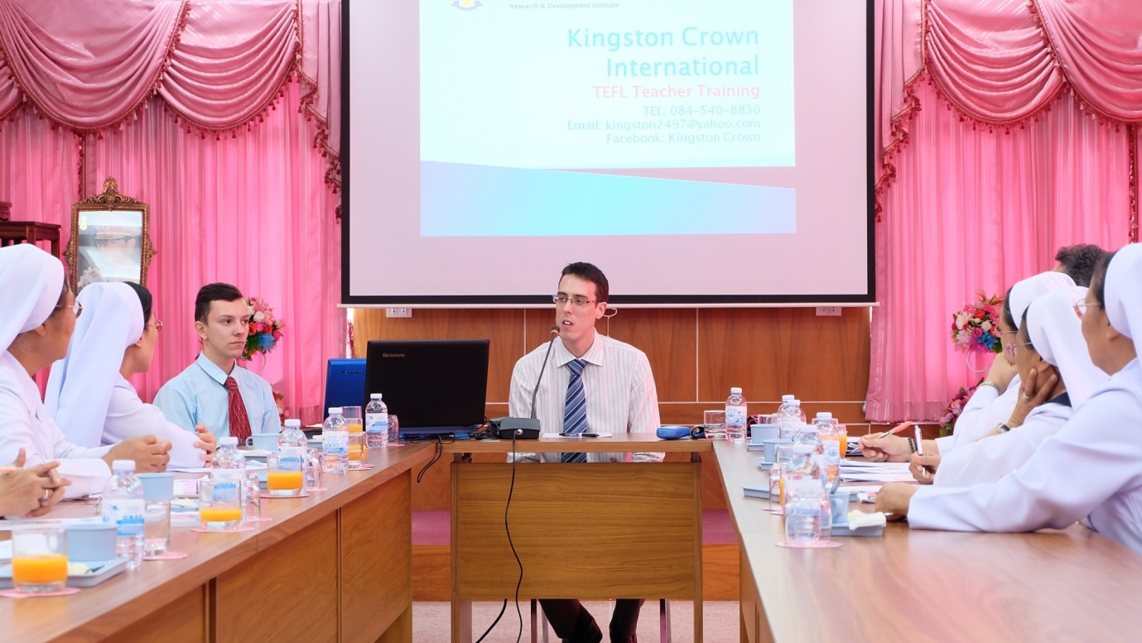
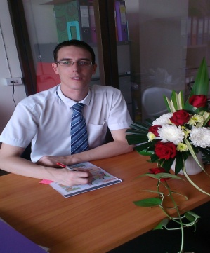
Name: Neil Evans, British (31).
Testimony: 'I joined KCI in January 2015. Since then I have gained invaluable experience of teaching, organizing seminars & projects. The quality of the training is a level above any TEFL course in Thailand.'

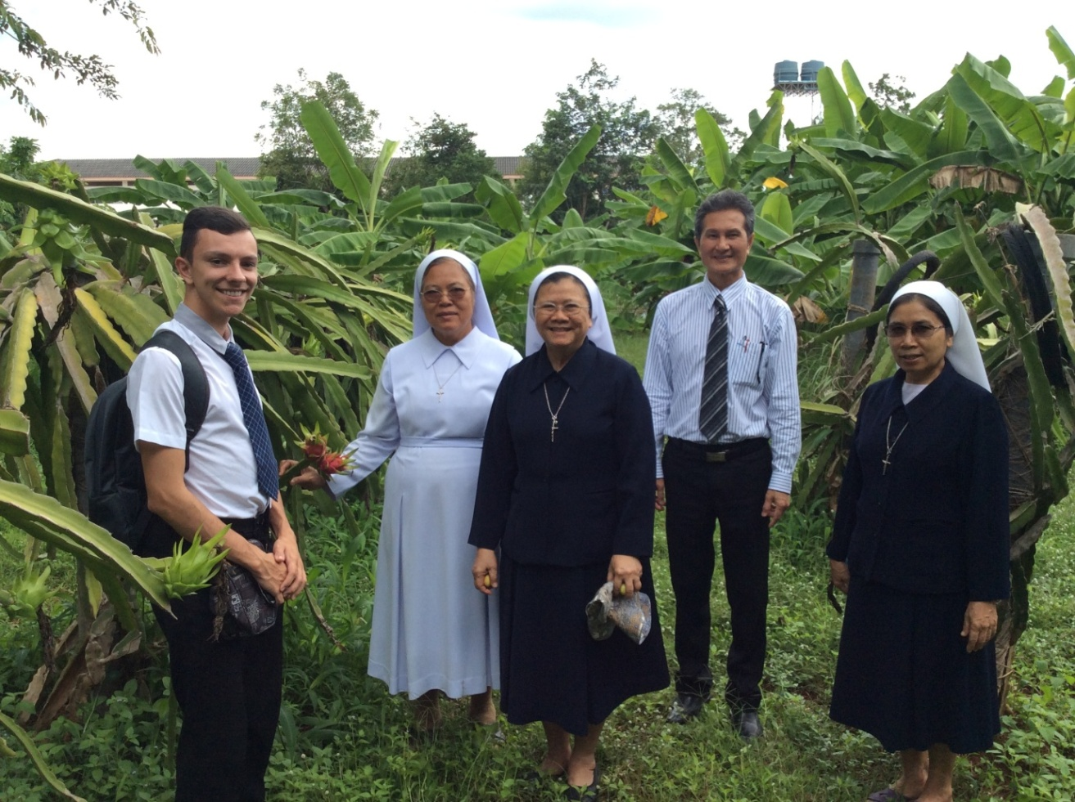
Name: Raivis Mumgaudis, Latvian (22).
Testimony: 'I joined KCI in August 2016 and have already learnt lots about teaching. The students are a joy to teach and I love the friendliness of Thai people. Thai food is amazing and I love my time here.'

